IT Structure, cours 4

Value chain : firm operates in specific industry to deliver product or service for the market

Support activities : firm infrastructure, human resource management, technology development, procurement

Corporate strategy -> business goal for IT -> IT strategy -> IT governance

IT department → (economic performance) → general management

IT department → (operational performance) → business units

Business units → (value creation) → general management

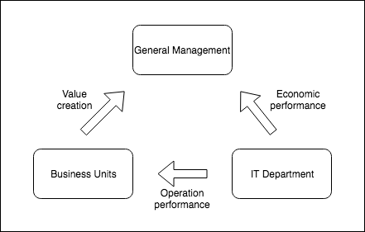

Equilibrium between Value = Cost vs Risk

Business unit ask for :

* IS and evolution
* Benefits are proven
* Contribution
* Communication

IT department must :

* Better control of risk and cost
* Constructive dialog
* Accountability
* Stronger efficiency
* Agility
* Innovation

IT must serve firm’s strategic objectives

Primary challenge ? Cost killing or innovation and business value

IT dept used to be cost centre

* Functioning costs
* Evolution costs poorly controlled
* Variable QoS

-> Now becomes strategic tool

* Shared challenge
* Key of value chain
* High standards of service delivery, inherent qualities, facilitated evolution

IT assures the daily regular service and brings innovation to the business

3 constraints :

* Value
* Budget
* Timeframe

But it lacks of maturity : new, must be always operational which is obstacle, rudimentary methods, prototype mindset, not on schedule

Rapid changing technologies : evolve fast, renovation cycles to shorten, increase in complexity

5 trends :

* Business alignment
* Value delivery : organization, asses ROI
* Risk management
* Resource management : sourcing, current and expected requirement
* Performance enhancement

Multiple “delivery” models

Centralized organization : poorly adapted to business needs

Decentralized organization : autonomous in management, redundant

Federal organization : global infra, application centralization, autonomy for local

Evolution trends to adapt to a new context

Reinforce business relationship

Ne service oriented

Implement an agile approach

Less and less technical job in DSI but more in service providers like engineering. DSI will need more impletators

**IT Management frameworks and processes**

Bring value to business through it services

Concepts & frameworks > transparency, compliance, performance

* Quality : ISO, SOX, BALE II with lean, agile, scrum
* Risk : quality, service, security : project, value-optimization
* Service : standardization & globalization : recommandation
* Conformity : all, IT

ITIL : International Technology Infrastructure Library

international empiric standard

Customer is heart of repository

Notion of service provided to the customer

Process approach

Common vocab

Generic

Towards a service life cycle

Service design : most implemented processes

* Service level management
* Capacity management
* Service continuity management
* Availability management

Timeline :

Incident management

Problem management

Change management

Release and deployment management

Configuration management

Agile manifesto

Methodologie SCRUM

DevOps : release functionalities after sprint

Infra as code : environments provisioning

Continuous delivery : release velocity

Application

Collaboration culture

Lean IT

* Eliminate wastes
* Accelerate processes
* Focus on added value

Waste :

* Transport
* Inventory
* Motion
* Waiting
* Over production
* Over processing
* Defects
* Skills
* -> TIM WOODS

Approach :

* Survey
* Interviews
* Gemba : added value here, the project floor on IT. Important step to know what is done in the field
* Data analysis

**IT Governance tools**

Data references

Data relevance and reliability

Update Data

Alignment on value, risk, resources, performance

SLA : Business units have contractual relationship with IT department

OLA : from IT to External Service Provider